Section 1: Case Summary

Scenario Title:
Keywords: | Tracheostomy emergency, Tracheostomy obstruction, Respiratory Distress
Brief Description of Case: | 48-year-old male with a recent tracheostomy presents in respiratory distress. The patient is unable to be oxygenated or ventilated through the tracheostomy tube. Learner must identify tracheostomy obstruction. Attempts to correct tracheostomy obstruction with suctioning and cuff deflation are not successful. Removal of the tracheostomy tube is required, followed by either oral intubation or placement of a new tracheostomy tube. The patient improves once oral or stomal intubation is performed. If tracheostomy tube is not removed, the patient worsens and goes into cardiac arrest secondary to respiratory failure.

Goals and Objectives
Educational Goal: | To review the management of tracheostomy obstruction and allow learners to practice an approach to an uncommon, but life-threatening complication of a tracheostomy.
Objectives:  (Medical and CRM) | - Anticipate and prepare for incoming critically ill patient  - Identify tracheostomy obstruction  - Perform corrective techniques for tracheostomy obstruction  Recognize when and how to intubate a patient with a tracheostomy, including the technique of placing a new tracheostomy tube
EPAs Assessed: | C1 Resuscitating and coordinating care for critically ill patients  C3 Providing airway management and ventilation

Learners, Setting and Personnel
Target Learners: | ☐ Junior Learners |  | ☒ Senior Learners |  |  | ☒ Staff
 | ☒ Physicians | ☒ Nurses |  | ☒ RTs | ☐ Inter-professional
 | ☐ Other Learners:
Location: | ☒ Sim Lab |  | ☒ In Situ |  |  | ☐ Other:
Recommended Number of Facilitators: | Instructors:1
 | Sim Actors:3
 | Sim Techs:1

Scenario Development
Date of Development: | April 28, 2021
Scenario Developer(s): | Drs. Nicole Durfey, M.D. and Kyle Santee D.O.
Affiliations/Institutions(s): | Kent Hospital / University of New England College of Osteopathic Medicine
Contact E-mail: | ksantee@kentri.org; ndurfey@kentri.org
Last Revision Date:
Revised By:
Version Number: | 1

Section 2A: Initial Patient Information

- Patient Chart
Patient Name: John |  |  |  | Age: 48 | Gender: M | Weight: 100kg
Presenting complaint: Shortness of breath
Temp: 37C | HR: 130 | BP: 150/90 |  | RR: 45 | O₂Sat: 80% | FiO₂: 100% NRB
Cap glucose: 6.7 mmol/L |  |  |  | GCS: E2 V unable to assess M4
Triage note:
EMS called by wife after sudden onset respiratory distress. Just released from rehab yesterday from severe motor vehicle collision 2 months ago. Tracheostomy in place. Sudden onset severe respiratory distress, hypoxic at 80% on a 100% NRB. ETA 5 minutes.

Allergies: None
Past Medical History:  Healthy until MVC 2 months ago with Traumatic brain injury, Tracheostomy, Splenectomy & Pelvis fracture |  |  | Current Medications:  None

Section 2B: Extra Patient Information

A. Further History
Include any relevant history not included in triage note above. What information will only be given to learners if they ask? Who will provide this information (mannequin’s voice, sim actors, SP, etc.)?

EMS: Tracheostomy placed 8 weeks ago due severe MVC and traumatic brain injury. Off of mechanical ventilation for 2 weeks ago, discharged from rehab yesterday. Was watching TV and wife saw him suddenly start to struggle to breath. Had been OK until this event. No laryngectomy.
B. Physical Exam
List any pertinent positive and negative findings
Cardio: Tachycardic, regular. No murmur. | Neuro: GCS E2M3, verbal unable to be assessed. No focal findings.
Resp: Tachypneic, severe accessory muscle use, diminished breath sounds bilaterally. | Head & Neck: Cuffed tracheostomy tube in situ. No signs of trauma, no crepitus, no bleeding, no infection.
Abdo: Normal | MSK/skin: Normal
Other:

Section 3: Technical Requirements/Room Vision

A. Patient
☒ Mannequin: Adult. (Surgical airway capability preferred to allow for tracheostomy tube in situ)
☐ Standardized Patient
☐ Task Trainer
☐ Hybrid
B. Special Equipment Required
Non-rebreather mask
Bag Valve Mask
Suction & inline suction catheters
Direct and/or Video Laryngoscopy
Standard airway equipment, including syringe for cuff deflation/inflation
Tracheostomy tubes, cuffed
C. Required Medications
Rapid Sequence Intubation medications
ACLS medications
D. Moulage
If possible, tracheostomy in situ.
100% NRB over nose/face. 2nd 100% NRB over tracheostomy. 18g IV in right antecub.
E. Monitors at Case Onset
☐ Patient on monitor with vitals displayed
☒ Patient not yet on monitor
F. Patient Reactions and Exam
Include any relevant physical exam findings that require mannequin programming or cues from patient
(e.g. – abnormal breath sounds, moaning when RUQ palpated, etc.) May be helpful to frame in ABCDE format.
Airway - Tracheostomy present, unable to ventilate via tracheostomy due to resistance
Breathing - Tachypneic, severe accessory muscle use, diminished breath sounds bilaterally
Circulation - Prolonged capillary refill, thready pulses
Disability - Withdraws to painful stimuli, GCS E2, M3, verbal unable to be assessed
Exposure - Normal

Section 4: Sim Actor and Standardized Patients

Sim Actor and Standardized Patient Roles and Scripts
Role | Description of role, expected behavior, and key moments to intervene/prompt learners. Include any script required (including conveying patient information if patient is unable)
EMS | Gives initial description as patient is transferred to bed, “Mr. Smith is a 48 year old man with recent tracheostomy placed 8 weeks ago for severe motor vehicle collision complicated by traumatic brain injury, splenectomy and pelvic fracture. He was discharged from rehab yesterday and his wife said that he was doing OK until just prior to arrival. He was sitting on the couch watching TV when he suddenly started having trouble breathing. She immediately called 911. On our arrival he was in severe respiratory distress with a pulse ox of 80%. We applied 100% NRB to both face and tracheostomy tube with no improvement to the pulse ox. Vital signs en route: 37°C, HR 130/min, BP 150/90, RR 45. He was agitated on our arrival, but now he is getting lethargic. 18g IV to right antecubital fossa.”  If asked, able to report that there is no history of laryngectomy.
Bedside Nurse | Skilled and helpful in assisting.
Respiratory Therapist | Skilled and helpful in assisting.  -Reports that unable to ventilate due to resistance when ventilation is attempted via bag-valve mask via the tracheostomy tube  -Prompts to removing the inner cannula and suctioning if not requested. Reports that unable to pass suction catheter.  -Prompts to deflate the tracheostomy balloon and reposition and reattempt suction/ventilation if not requested. Reports that unable to suction/ventilate even with cuff deflation and repositioning.

Section 5: Scenario Progression

Scenario States, Modifiers and Triggers
Patient State/Vitals | Patient Status | Learner Actions, Modifiers & Triggers to Move to Next State |  | Facilitator Notes
1. Pre-arrival and preparation | En route | Expected Learner Actions  Gathers team & delegates anticipated initial tasks (Nurse, RT, 2nd provider for airway)  Anticipated priorities and shares mental model with team (sudden onset respiratory distress in tracheostomy patient, differential includes tracheostomy obstruction/displacement, pneumothorax, pulmonary embolism. Will start with assessment of the tracheostomy tube)  Gathers supplies for possible tracheostomy obstruction (BVM, suction, syringe to deflate cuff, intubation supplies, cuffed tracheostomy tube, RSI meds) | Modifiers  Triggers  -All actions completed or 5 min into case  → 2. Initial Resuscitation
2. Initial Resuscitation  Rhythm: Sinus tach  HT: 130  BP: 150/90  RR: 45  O2SAT: 80% (NRBx2)  GCS: E2,M3. Unable to assess verbal. | Severe respiratory distress. Lethargic, not following commands. | Expected Learner Actions  Monitors/IV  100% oxygen to both oropharynx & tracheostomy  Obtain pertinent history from EMS, including when tracheostomy was placed & that no history of larygnectomy  Primary Assessment- recognizes airway & breathing compromise  Verbalizes need to rule out tracheostomy obstruction and/or displacement. Asks RT to attempt ventilation through tracheostomy. | Modifiers  -RT reports unable to ventilate with BVM through tracheostomy because too much resistance  Triggers  -Completion of all actions→  3. Obstruction and/or Displacement Confirmed  OR  -If BVM ventilation not attempted through tracheostomy, pulse ox decreases, GCS decreases. After 5 minutes, RT prompts that tracheostomy may be obstructed or displaced and that should attempt BVM through tracheostomy. →  3. Obstruction and/or Displacement Confirmed | If unable to have tracheostomy in situ, have tracheostomy tube at bedside to demonstrate
3. Obstruction and/or Displacement Confirmed |  | Expected Learner Actions  Verbalizes that tracheostomy is either obstructed or displaced  Asks RT to remove inner cannula & perform suction.  When not successful, asks RT to deflate cuff and reattempt suction. Verbalizes that cuff deflation may resolve partial displacement.  When not successful, immediately removes tracheostomy tube  Verbalizes need for definitive airway | Modifiers  -When asked, RT removes inner cannula, attempts to pass suction catheter but it does not pass  -When asked, RT deflates tracheostomy cuff and attempts to pass suction catheter but it does not pass. Still unable to ventilate.  Triggers  -Completion of all actions→  4. Definitive Airway  OR  -If does not remove tracheostomy, then patient’s pulse ox decreases, followed by bradycardia and cardiac arrest. ROSC when tracheostomy tube removed & definitive airway placed.
4. Definitive Airway |  | Expected Learner Actions  Ventilate/oxygenate patient orally using BVM while sealing tracheostomy stoma (such as with gloved hand)  Perform either oral intubation or intubate the stoma  If oral intubation, verbalizes need to inflate the ETT balloon past the stoma  If stoma intubation, uses either new tracheostomy tube or 6-0 ETT. Performs procedure correctly.  Provide ventilator settings and post intubation sedation | Modifiers  -Improved O2 sat to 95% using BVM orally with tracheostomy stoma sealed. Heart rate improves. Patient remains with low GCS requiring intubation.  Triggers  -Completion of all actions→  5. Disposition | If tracheostomy in situ not available, have Learner verbalize technique of placing new tracheostomy tube:  - Neck slightly extended  - Lubricate tracheostomy tube. Obturator in place.  - Insert stoma at 90° angle, push tube downward in fluid, sweeping motion  - Remove obturator. Insert inner cannula.  Inflate cuff & ventilate.
5. Disposition  Rhythm: Sinus  HR: 90  BP: 130/80  RR: 20  O2SAT: 100% on 40% FiO2 |  | Expected Learner Actions  Discuss with ICU physician for hand-off | Modifiers  Triggers  -Transfer to ICU → End Case

Appendix A: Laboratory Results

None provided during case

Appendix B: ECGs, X-rays, Ultrasounds and Pictures

Image #1 (for debrief)- Components of tracheostomy tube

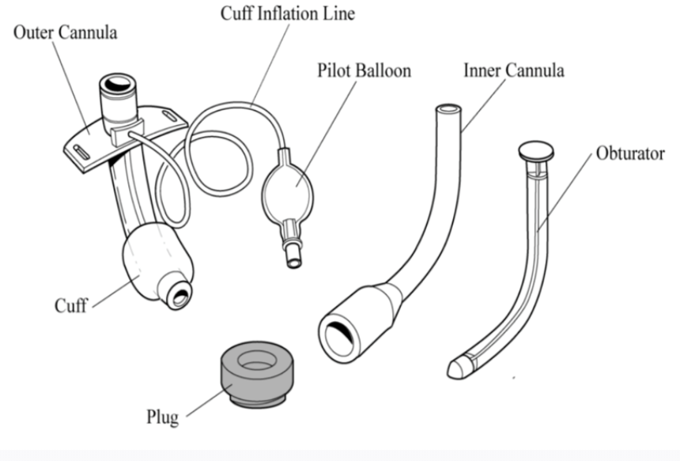

Image source: https://epmonthly.com/article/managing-tracheostomy-patient/

Image #2 (for debrief)- Partially displaced tracheostomy tube with the cuff obstructing the trachea

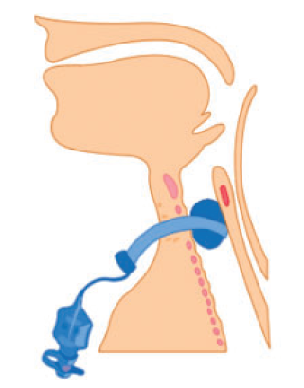
Image source: McGrath BA, et al. Multidisciplinary guidelines for the management of tracheostomy and laryngectomy airway emergencies. Anaesthesia. 2012, 67: 1025-1041

Image #3 (for debrief)- Partially displaced tracheostomy tube with the cuff obstructing the trachea

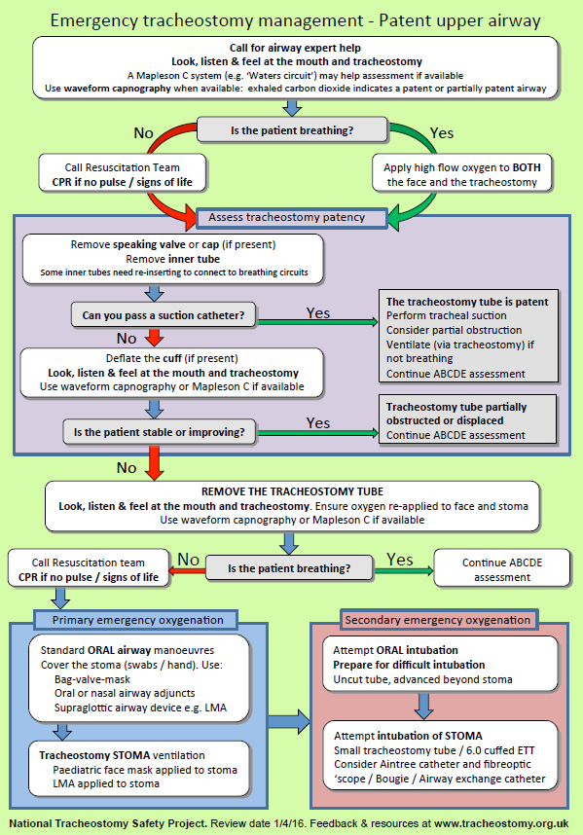
Image source: http://www.tracheostomy.org.uk/storage/files/Patent%20Airway%20Algorithm.pdflaryngectomy airway emergencies.

Appendix C: Facilitator Cheat Sheet & Debriefing Tips

Sample Debriefing Questions:

- What are the different components of a tracheostomy tube? What are their purposes?
-See Image#1. Outer cannula remains in the tracheostomy site and keeps it open. Most tracheostomy tubes also have an inner cannula that is removable to allow for cleaning. The obturator is a solid device used to insert the tracheostomy, the obturator is removed after insertion.

- What are the most common causes of sudden respiratory distress in a tracheostomy patient?
-Obstruction: Simply removing the inner cannula and suctioning often relieves an obstruction. Generally the inner cannula will need to be in place to connect the patient to the BVM or ventilator, so it will need to be cleaned or replaced if it is obstructed
-Displacement: Deflating the cuff may correct a partially displaced tracheostomy tube. See Image#2

- What are the initial steps to management of the crashing tracheostomy patient?
See Image #3. Emphasize that a tracheostomy tube that is not functioning because it is obstructed or displaced must be removed.

- What important information must be obtained about the tracheostomy patient?
-Has the patient had a laryngectomy? If yes, since the larynx is removed, the upper airway is not connected to the trachea. Oral ventilation and oral intubation are impossible in the laryngectomy patient. They must be ventilated/intubated through the stoma.
-When was the tracheostomy performed? If the upper airway is patent (ie, no laryngectomy), and the tracheostomy is less than 7 days old, then oral intubation is preferred.

- How is the emergency intubation of the stoma performed?
  - Start with a size smaller than removed tracheostomy tube. Can also use 6.0 ETT.
    - Neck slightly extended.
    - Lubricate tube. Obturator in place
    - Insert into stoma at 90° angle. Push tube downward in fluid, sweeping motion.
    - Remove the obturator. Insert the inner cannula.
Inflate the cuff & ventilate.

References

- McGrath BA, et al. Multidisciplinary guidelines for the management of tracheostomy and laryngectomy airway emergencies. Anaeshesia. 2012, 67: 1025-1041.
- http://www.tracheostomy.org.uk/healthcare-staff/emergency-care/emergency-algorithm-tracheostomy Accessed April 28, 2021

